HP SADDLE – LATEST FEEDBACK

June 2019

Thanks John. Lovely Saddle. Kate Hazeltine. N.S.W.
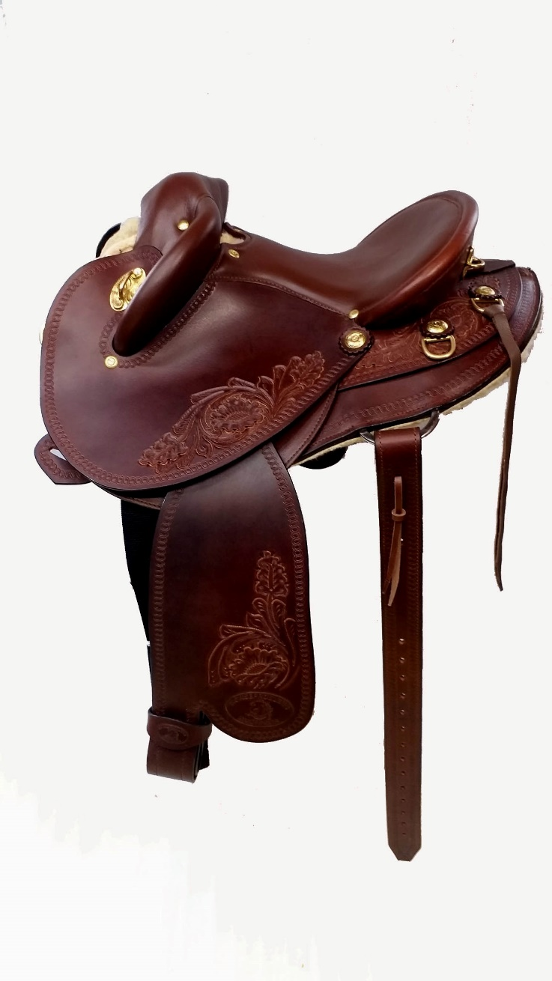

HOLLAND

Hi Linda and John,
Received the Saddle on friday, al good! It fits well. See photo in the annex, isn't she pretty with her brand new saddle?
At first, she refuses to walk with it. Its a smart little horse, she thinks, if I don't walk I don't feel that weird thing under my belly.
Then she gave a few Bucks, but today that already was less. She'll soon be used to it.
I want to thank you and John for the quality and fast, correct delivery of the saddle. So far, I am very happy with it!
With kind regards,
Betty and Indie

ENGLAND

The Saddles arrived safely. Thanks for your putting up with us for Weeks, getting things all right. Regards

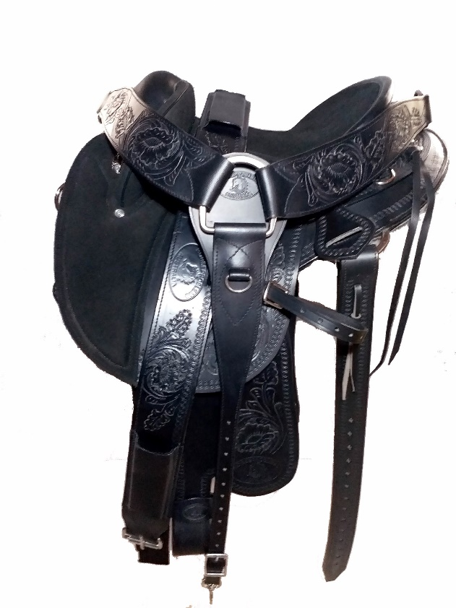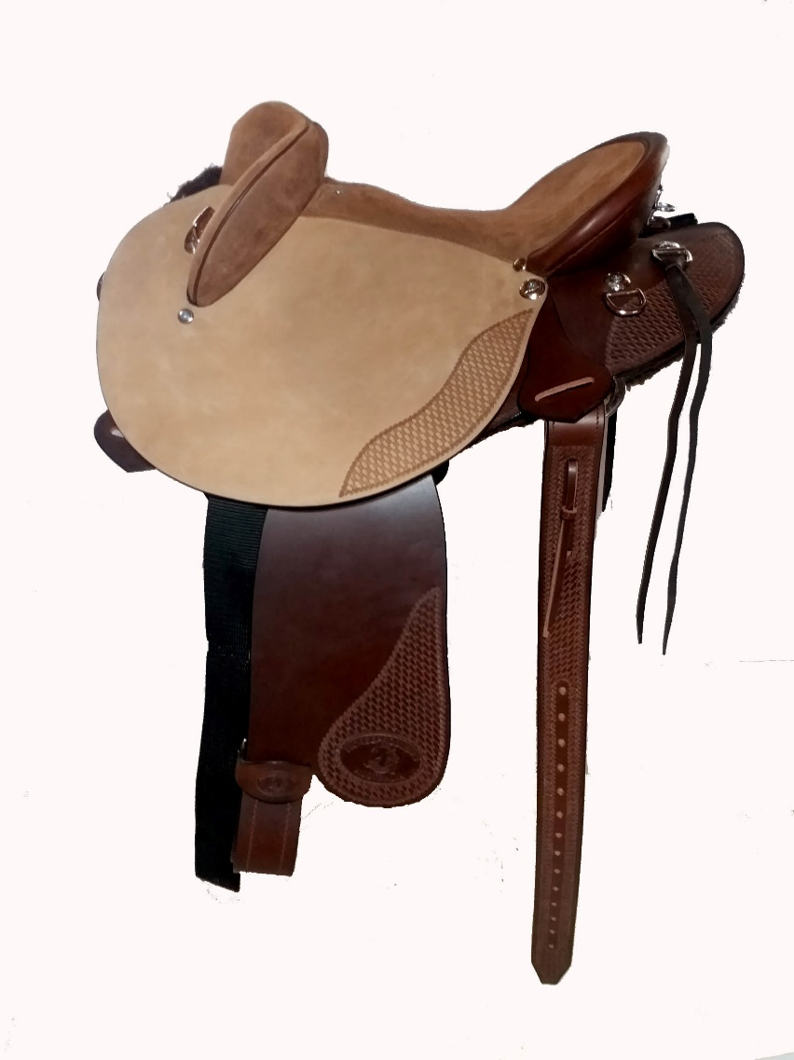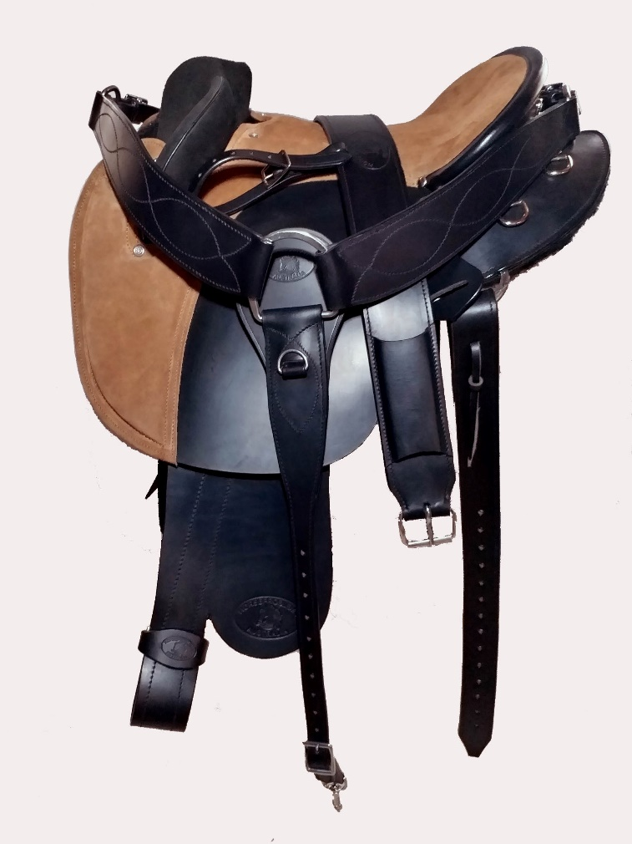
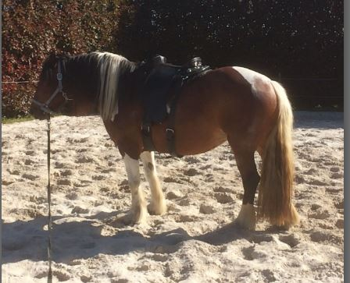

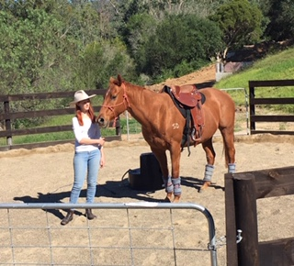

Dear John and Linda
Thank you both for helping me through the ordering process a few weeks ago.
I was the customer who confused myself re payments, also confused both of you, and I don’t manage internet banking well so had to speak to a real human at the bank for assistance, who ended up laughing with me.
I am still embarrassed and cannot apologise enough for wasting your time.
The saddle is so beautiful and you were both so great to deal with.
I love it. Here is a picture of our mare and my daughter modelling the latest fashion. It is Australian Fashion Week, after all!
As you said, a few bucks in the round yard getting used to it but quickly settled within five minutes.
We look forward to using it for many years.
Thanks again.
Best regards Janice

18th June, 2017
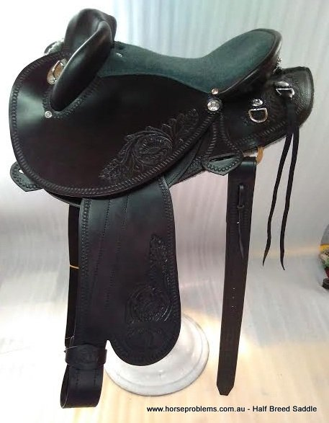 Just had to say spent 4 hours riding in my new saddle yesterday, not a mark on my girl and no neck or shoulder spasms like I have gotten for the past decade. In fact there were two HP saddles on yesterday's ride. Just so good. Carly Sutherland

HP SWINGING FENDER SADDLES - ENGLAND
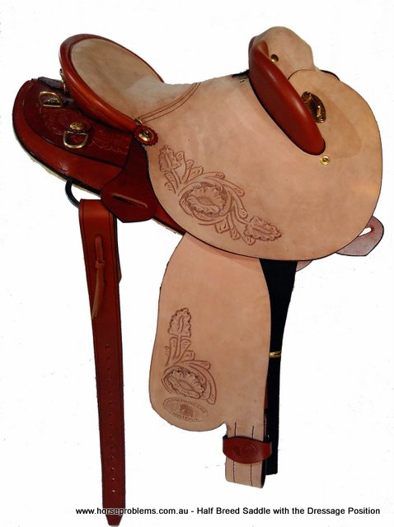

Denise Woodhouse reviewed Horsemanship Saddlery UK – 5 star 13 hrs · Great service and great saddles. Maureen was very helpful letting me trial a saddle to see what I, and most importantly what my horse, thought to it. After deciding to order she was also very helpful recommending certain features and checking through the form to make sure everything was correct before the order was placed. I love the fact that you can customize the saddles to your specifications and the quality and workmanship is excellent. I have ridden in it a few times now and love the secure feeling it gives you and how comfortable it is for both myself and my horse,

Here is a testimonial received today about your saddle for Kevin Woodhouse:
“Hi Maureen, A short message to say I rode my very 'flashy' HP saddle today, I have to say I have sat in both English and Western saddles but this is the most comfortable saddle I have sat in, Also being a novice rider I found myself sitting in a perfect dressage position without any effort or thought on my part and felt very secure. Our horse Skye moves much more freely in the saddle too, lifting her back and carrying herself nicely, makes me look like I am a better rider than I actually am. Thank you for your help and advice and please pass on my thanks to John for developing such a great saddle.” Keep it going!.

